WebSocketSDK Sample for Win8
(M50, M60, M70)
2018/1/8
- System Requerements
Item | Supported | Tested
OS | Win 8 / Windows 2012 Server, or Later | Win8, Win10
IIS | IIS 8, or Later | IIS 8, IIS 10
ASP.NET | 4.5, or Later | 4.5
Internet Explorer | IE10, IE11 | IE11
Visual Studio | 2010 / 2012 / 2013 / 2015 | VS2013, VS2015
M50, M60, M70 FW | v2.2.6 20151027 or Later | v2.2.9

- Prepare Firmware
- Set Active Client Mode.
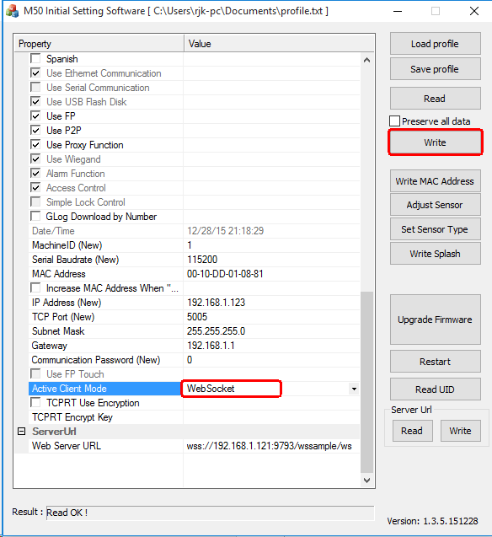
- Set Device Serial Number
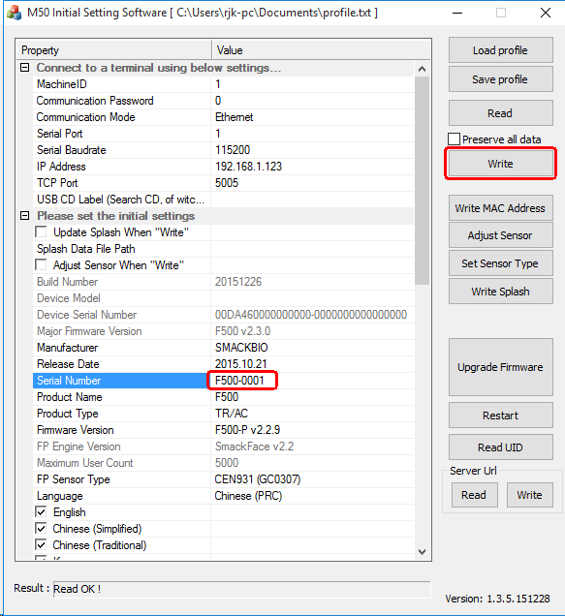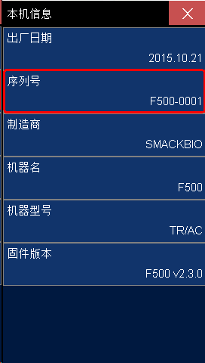
- Set WebServer Address.
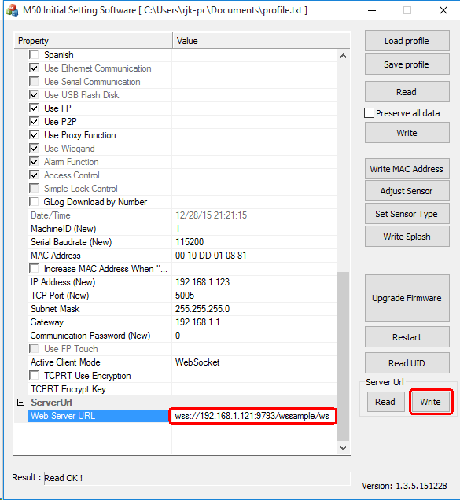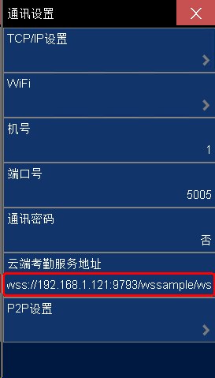
- Restart the M50.
- IIS Configuration
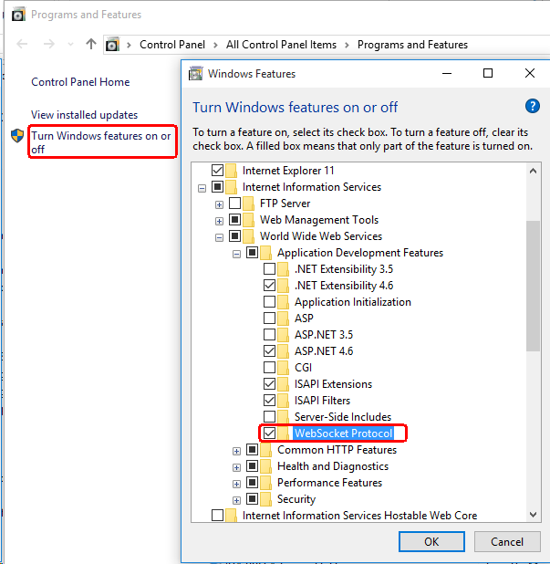 | 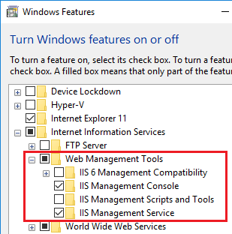
 | 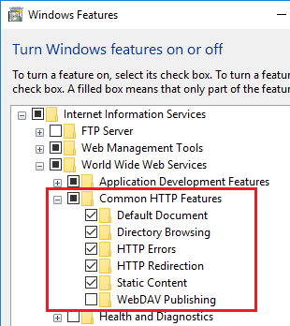
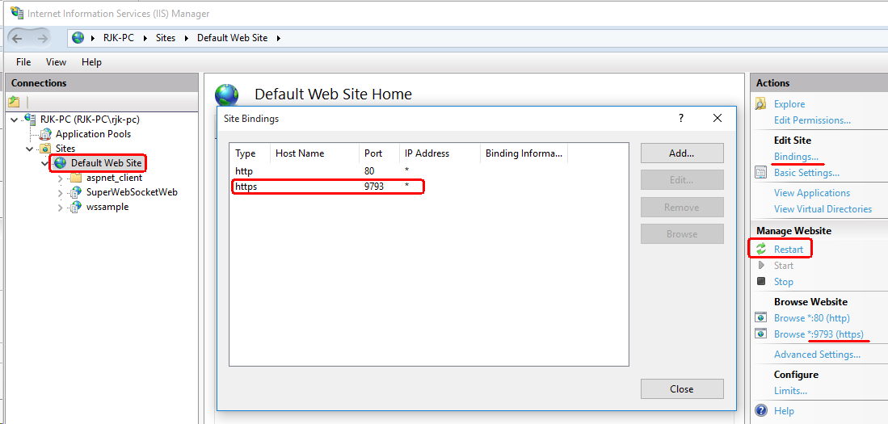
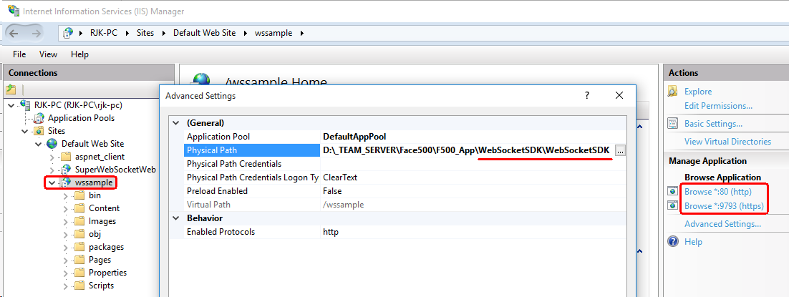
- WebSocketSDK Sample Configurations and Run.
